PERTH MODERN SCHOOL


Yr 11 Mathematics Specialist

INVESTIGATION 2

Part A: TAKE HOME

Notes from this part may be used for the in class validation. You must also save the work done on your CAS Calculator as it will be needed for the in class validation.

Modelling Periodic Motion with Trigonometric Functions
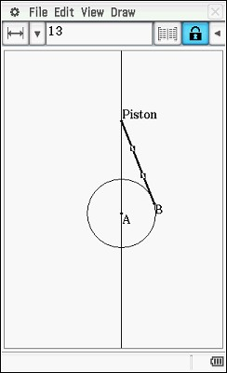
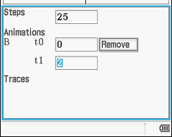
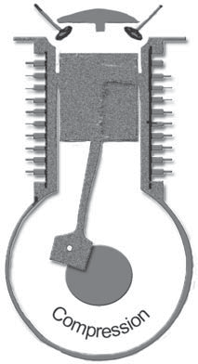

An internal combustion engine works by small amounts of fuel igniting in a chamber causing a piston to move away from the explosion. The linear motion of the piston is transferred down through the connecting rod and into circular motion via a crankshaft. See the diagram at right.
In this activity you will create an animation to model the motion of a piston and the rotating crankshaft.

Construction
- Open the Geometry application and select [File | New] if necessary
- Cycle through the axes options until the background is blank
- Draw a circle and constrain its centre to (0,0) and radius to 5 units
- Draw a line and change its equation to x = 0
- Hide the points on the line for neatness
- Draw a line segment from the point on the circumference to a point on the vertical line above the circle
- Constrain the length of the line segment to 13 units

Add Animation
- Select the point on the circle (B in the diagram) and the circle
- [Edit | Animate | Add Animation]

Edit Animation
- [Edit | Animate | Edit Animations]
- Modify the settings as shown

Run the Animation
- [Edit | Animate | Go (once)]

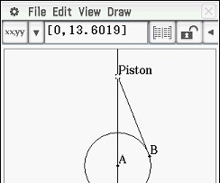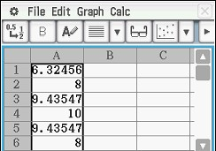
Measure the height of the piston
- Select the Piston point
- In the measurement pull down menu ensure co- ordinates x are selected
- Tap #, the table button
- Select column x then [Edit | Delete]
Graph the data
- Select the column of data
- [Edit | Copy]
- Open the Spreadsheet application
- [File | New] if necessary
- [Edit | Paste] the values
- Draw a scattergraph X of the data

- Describe the shape formed by the points in the scattergraph.

- Point A (the centre of the 5 unit radius crankshaft) is 0 units high. Given that the connecting rod is 13 units long, and that the animation starts with
θ = 0 , explain why the piston is initially 12 units high.

- What are the maximum and minimum heights of the piston?

- Suppose the crankshaft is rotating at 600 revolutions per minute (a typical idle speed for a large motor vehicle engine).
  - How many revolutions are completed per second?

  - Hence, what is the period of the graph?

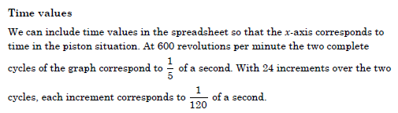
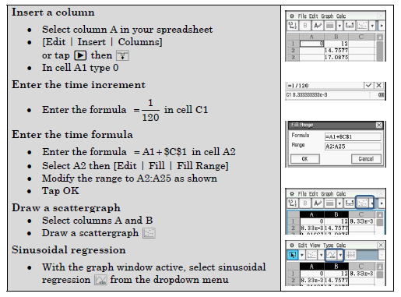
- Write down the sinusoidal regression equation. (Make sure your Classpad is set to Radians).

- Explain the meaning of each of the parameters (a, b, c and d) in the context of the movement of the piston.

Did you notice that the c and d values in your regression equation were not quite what was expected? The issue arises from the fact that the piston’s position as measured in the animation is not varying perfectly sinusoidally with time.
Consider the diagram shown below. The angle θ is varying with time and the height of the piston y is dependent on the angle and hence time. Let x represent the time in seconds.
We will assume the crankshaft is still rotating at 600 revolutions per minute.
- Explain why:
$a) θ=20πx$ | 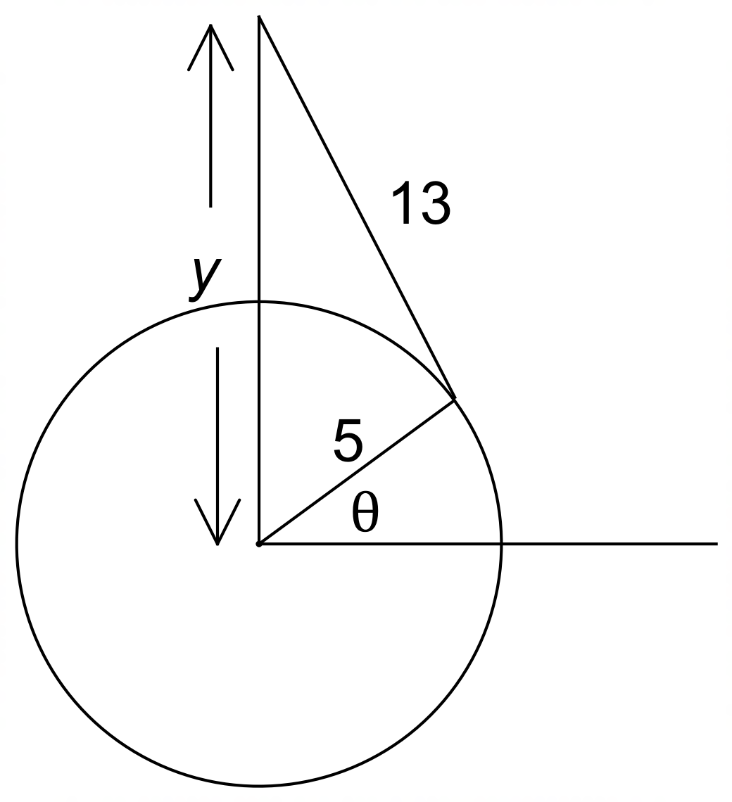

b) ${13}^{2}=5^{2}+y^{2}-10ycos(\frac{π}{2}-θ)$

- Use CAS to combine the two equations in Q1 to obtain an equation for the height of
the piston (y) in terms of time (x).

END OF TAKE HOME SECTION: RETAIN NOTES AND CLASSPAD WORK
FOR IN CLASS VALIDATION

